Bi-weekly assignment week 5&6 report
Name: Kriti pradhan
Level-3
Section-’c’
Module: Fundamentals of Data Science
File Handling and Object-Oriented Programming
Count Lines, Words, and Characters
This program reads a text file and counts the number of lines, words, and characters.
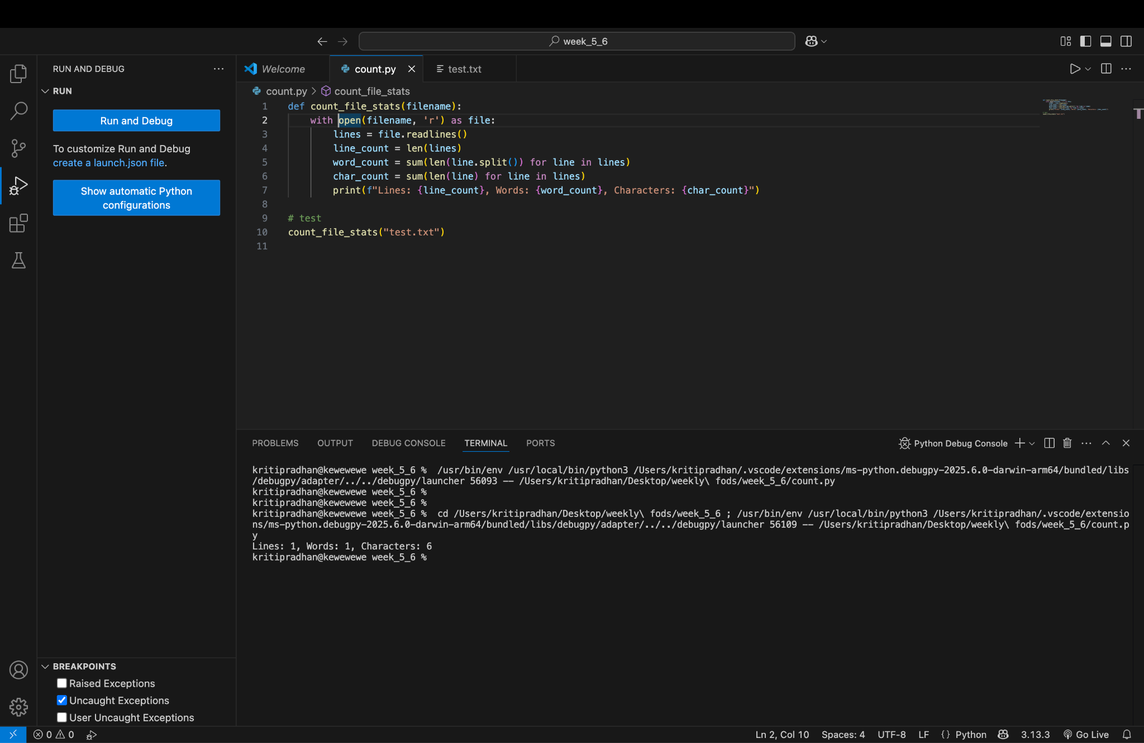
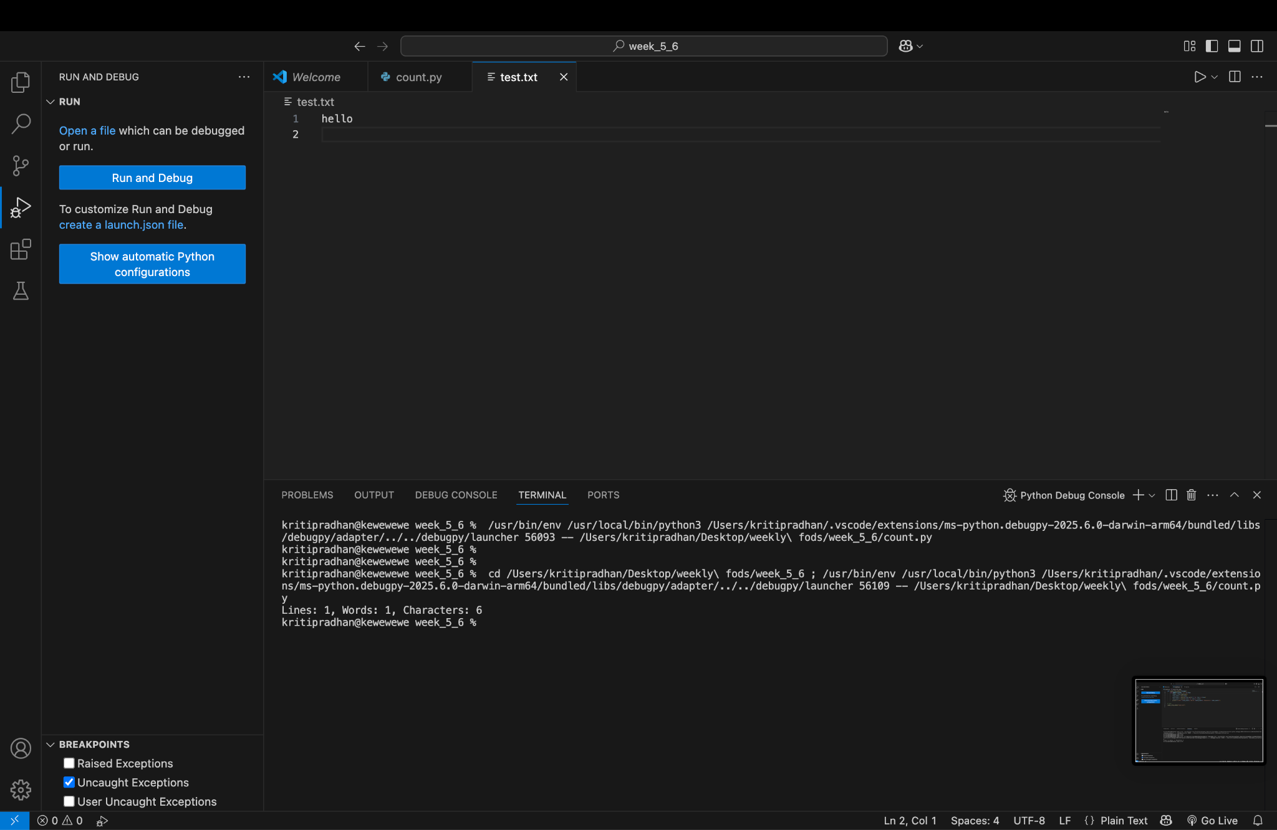
Copy File Contents
This program copies content from one file to another.
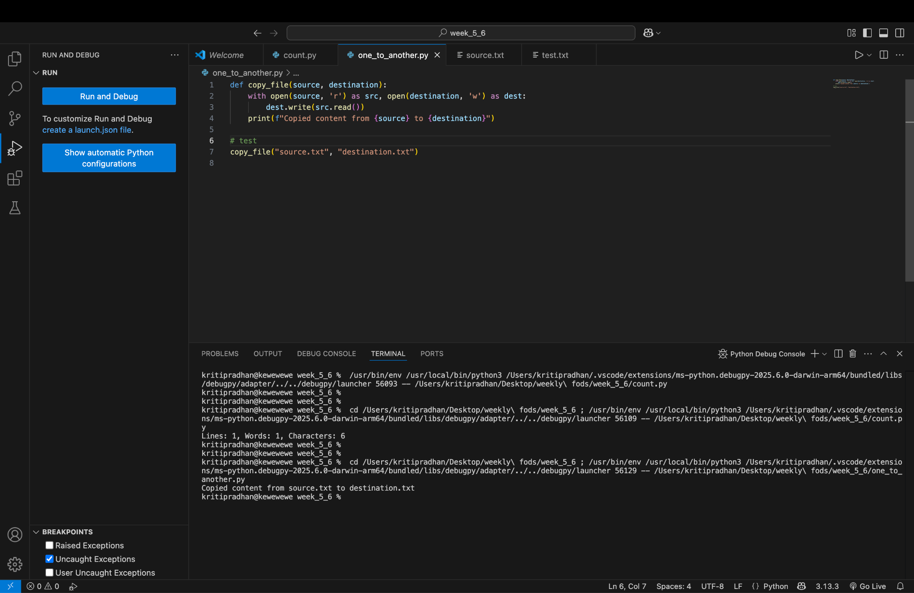
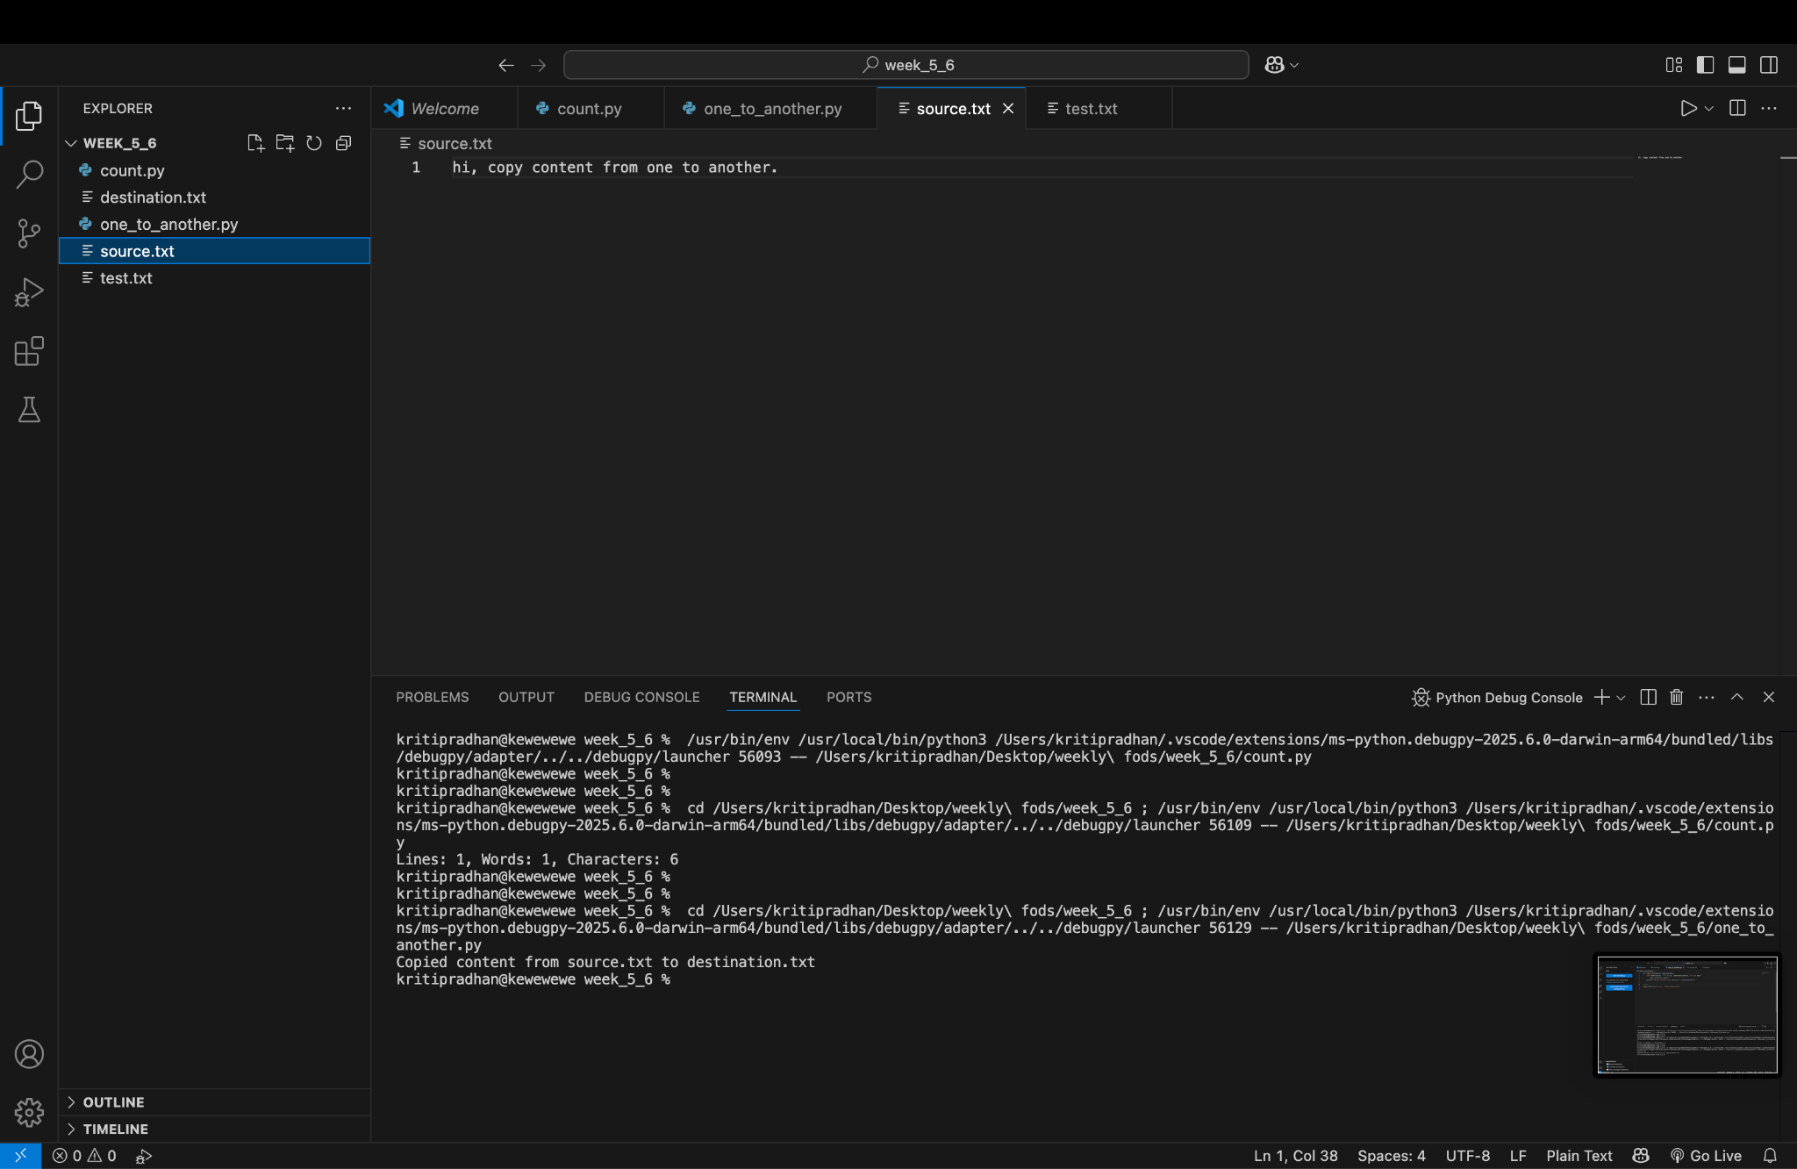
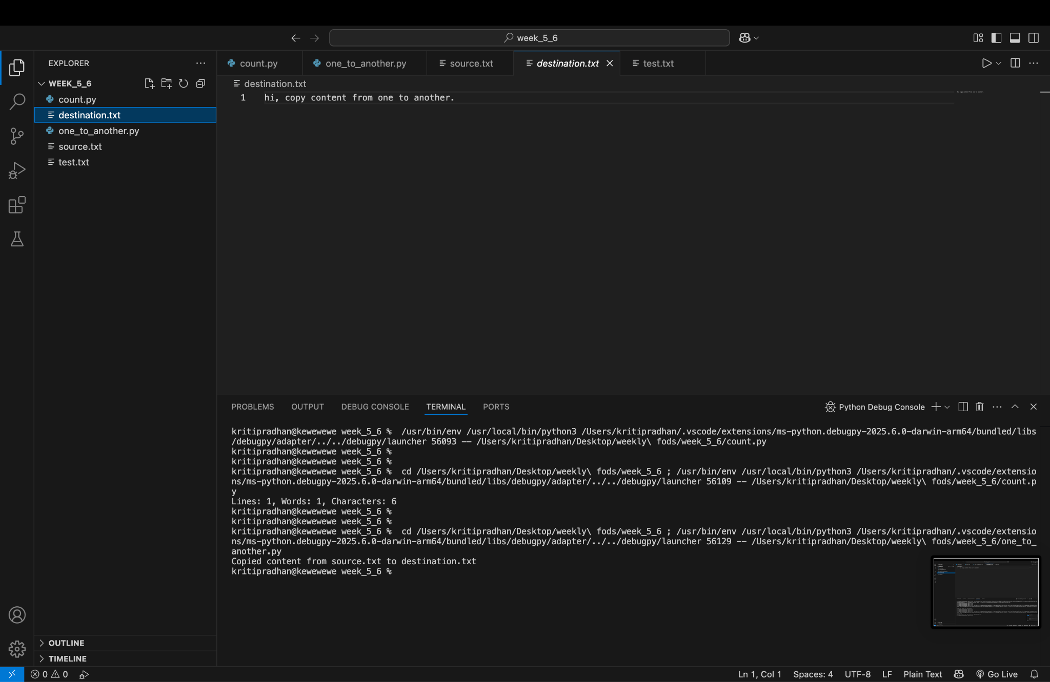

Find and Replace Word in File
This program replaces all occurrences of a specific word in a file with another word.
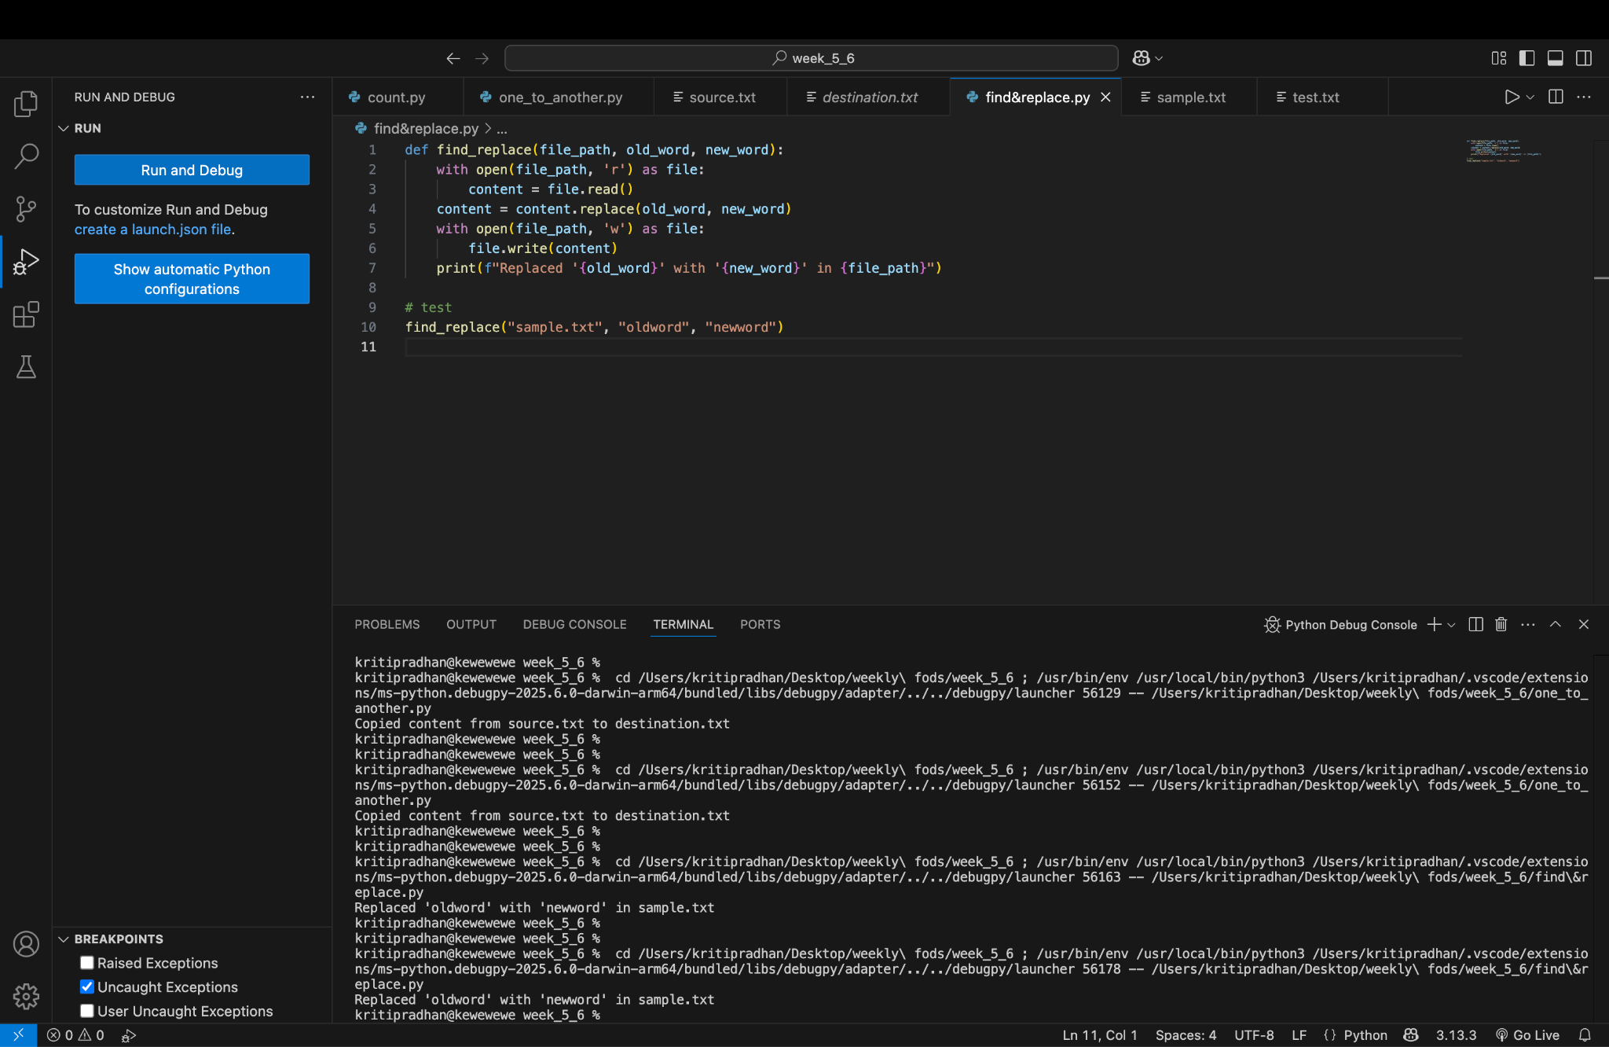
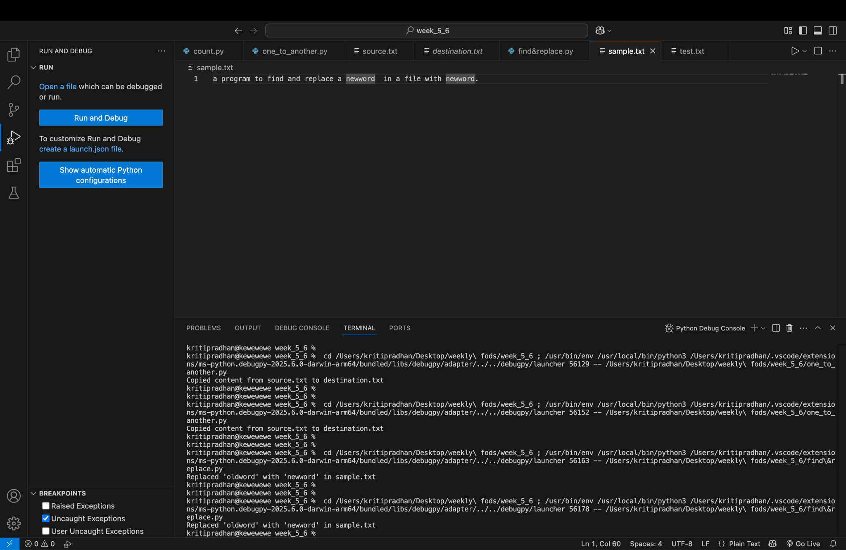

Display CSV File in Tabular Format
This program reads a CSV file and prints its contents in a structured tabular format.
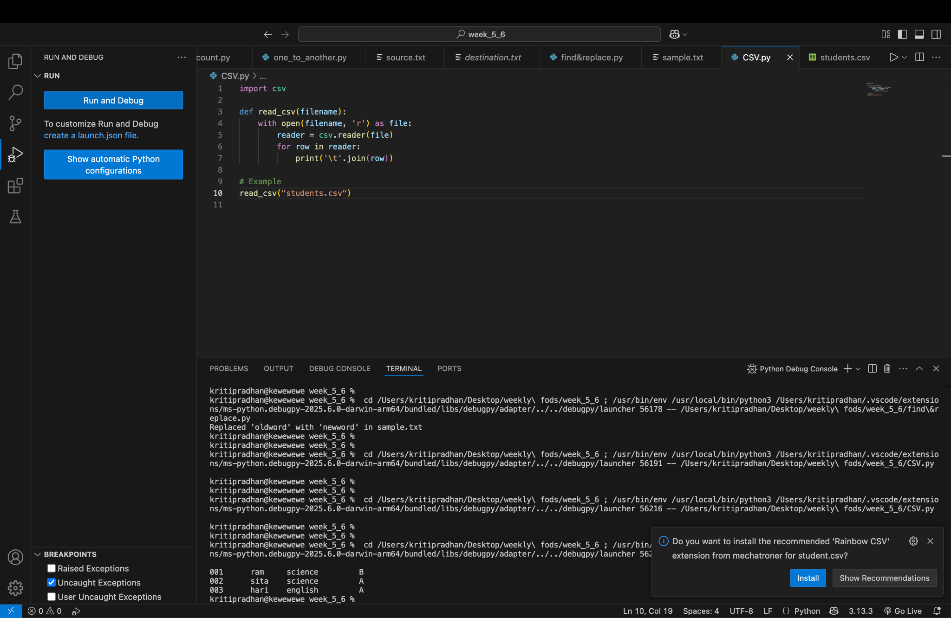
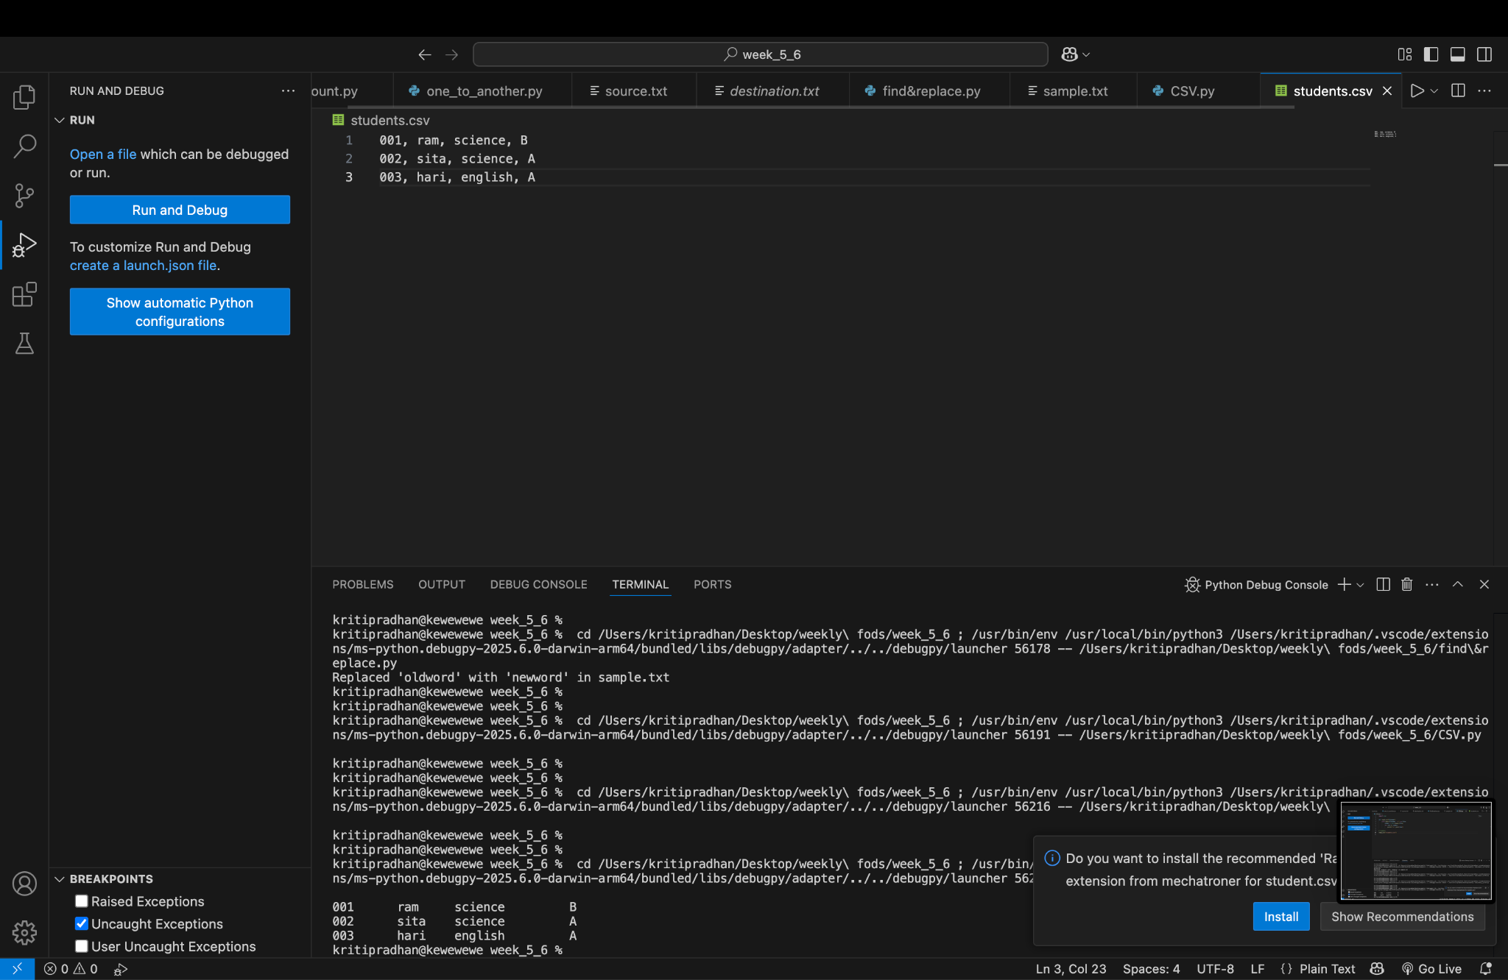

Word Frequency Counter
This program counts how many times each word appears in a file.
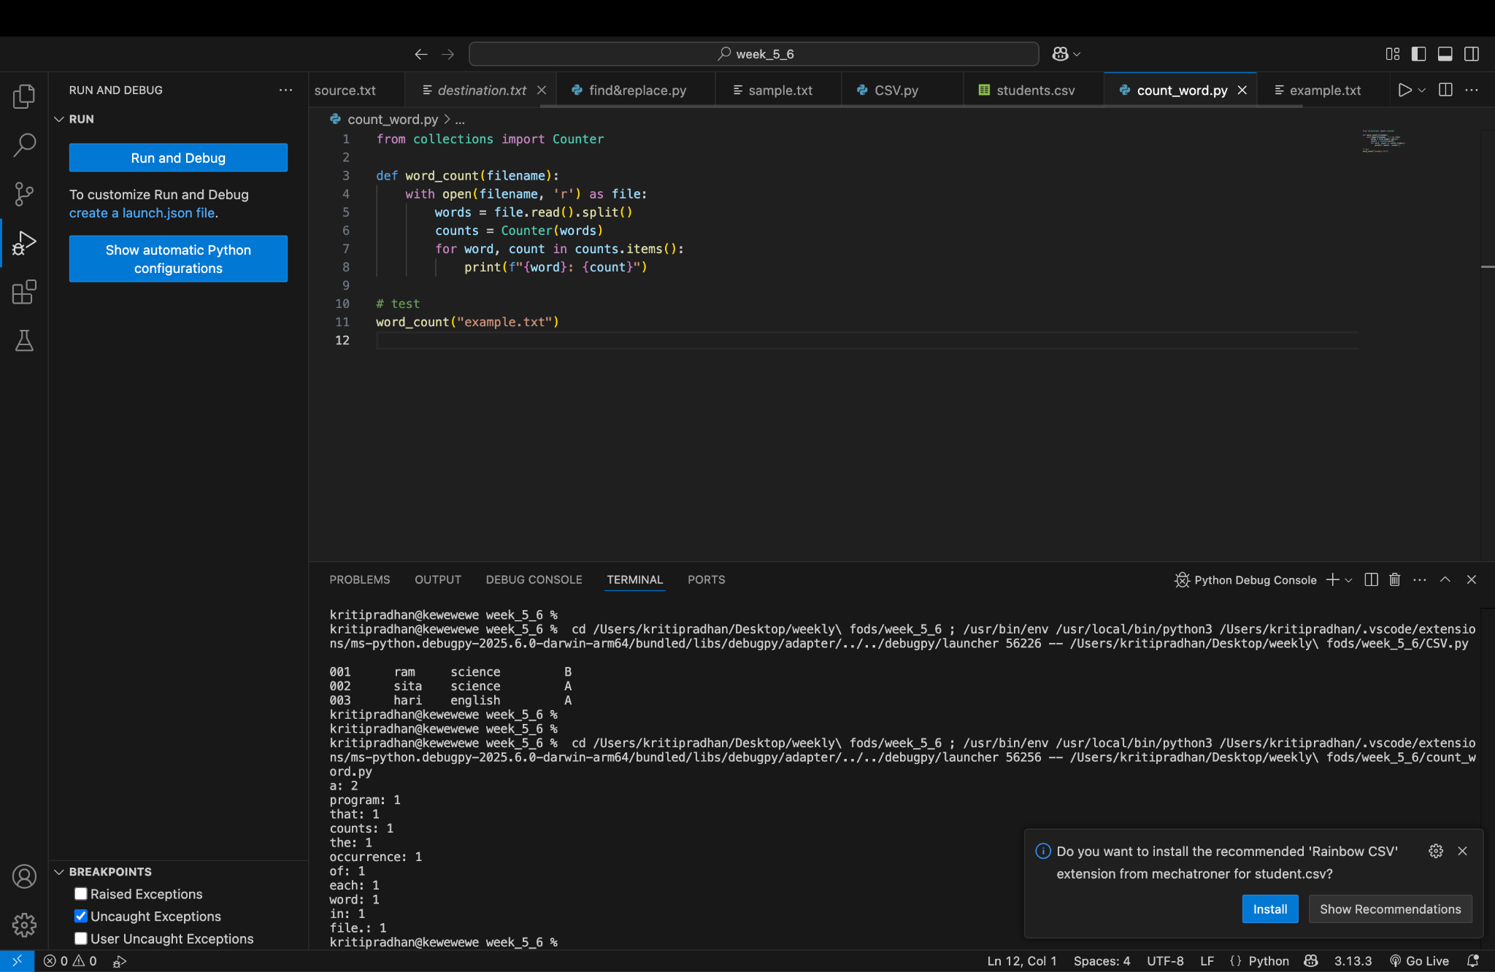
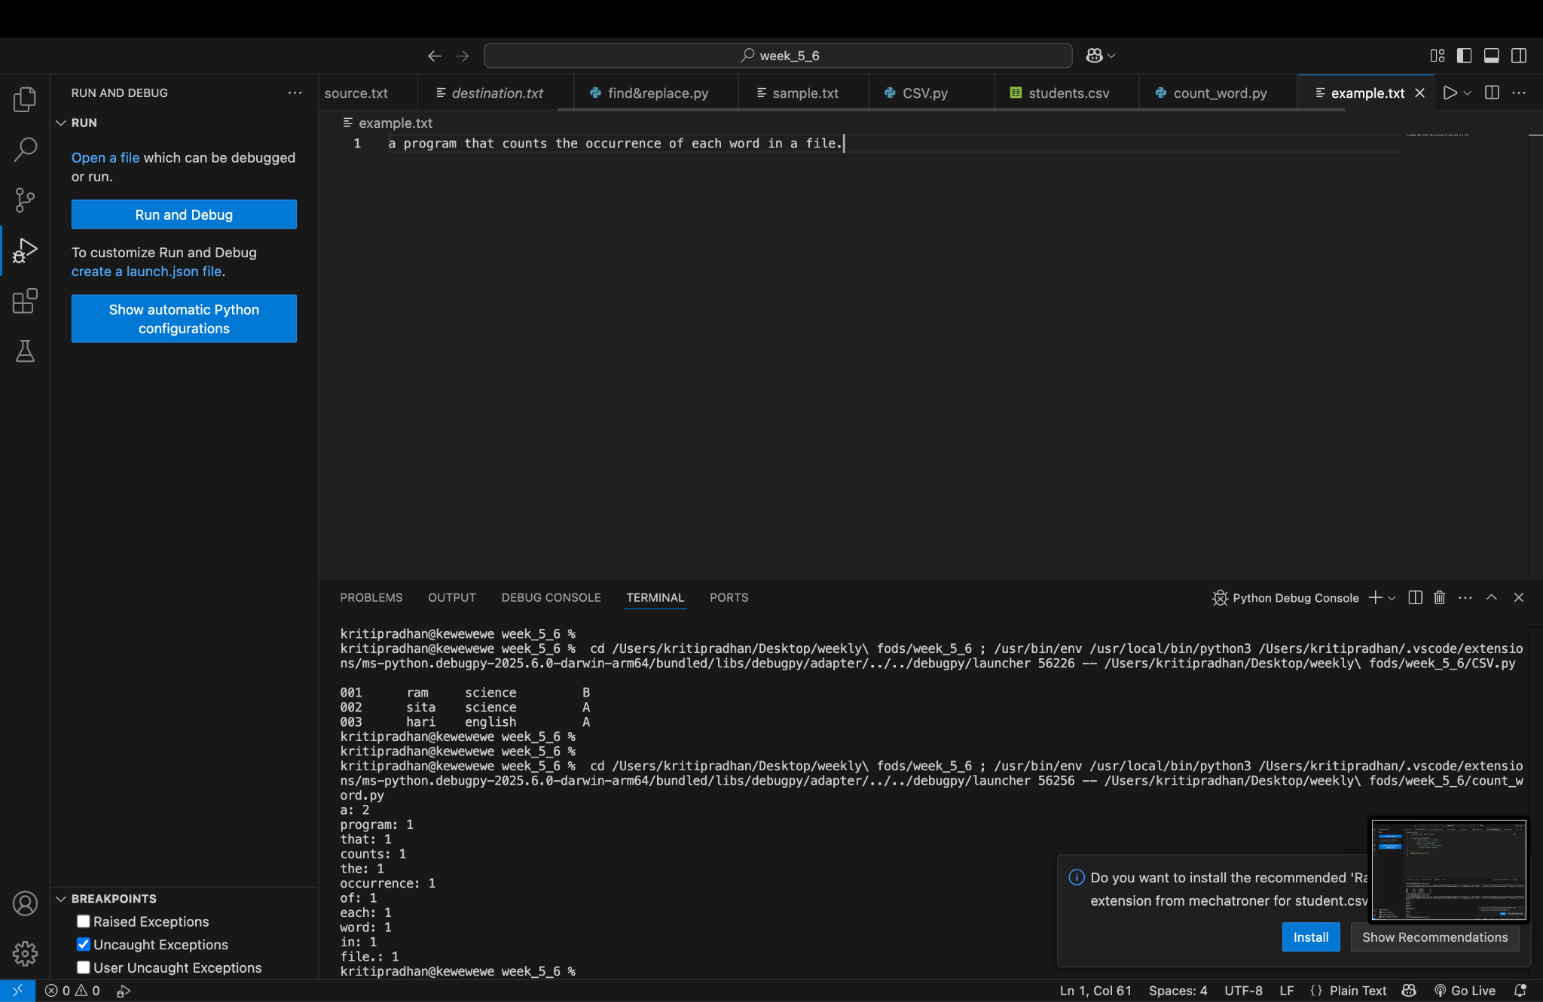

Student Class
This program defines a Student class, takes input for student attributes, and displays them.
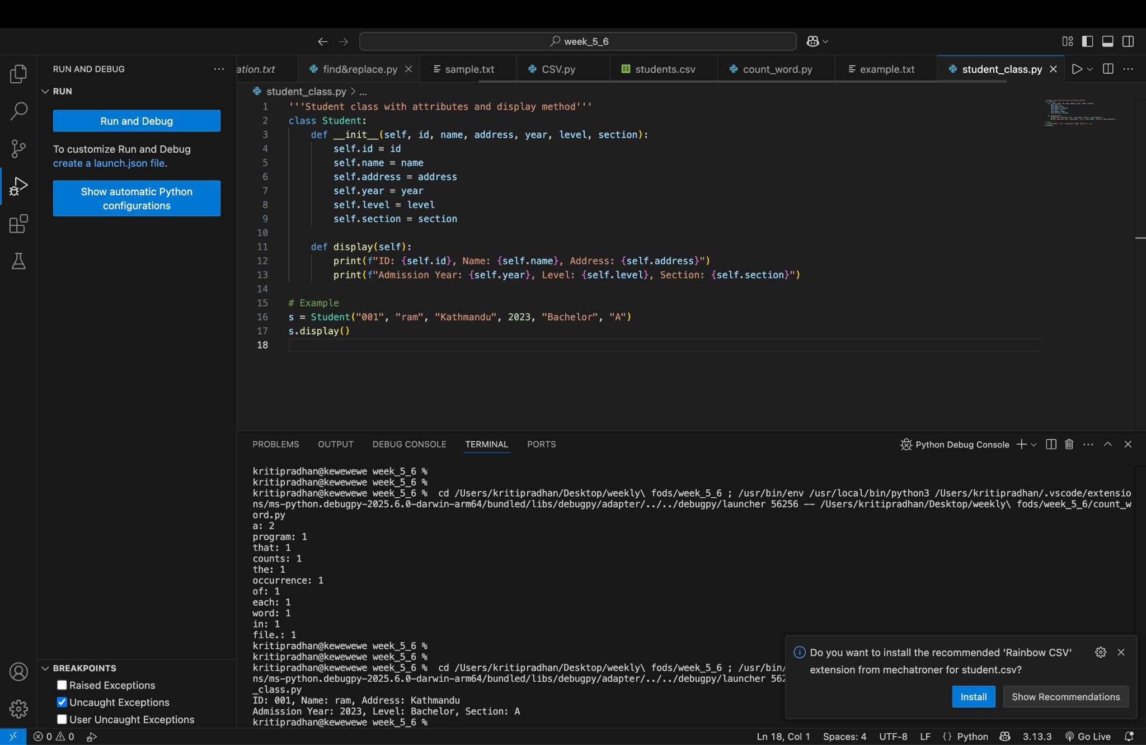
Employee Management to CSV
This program uses an Employee class to input, save, and display employee records in a CSV file.
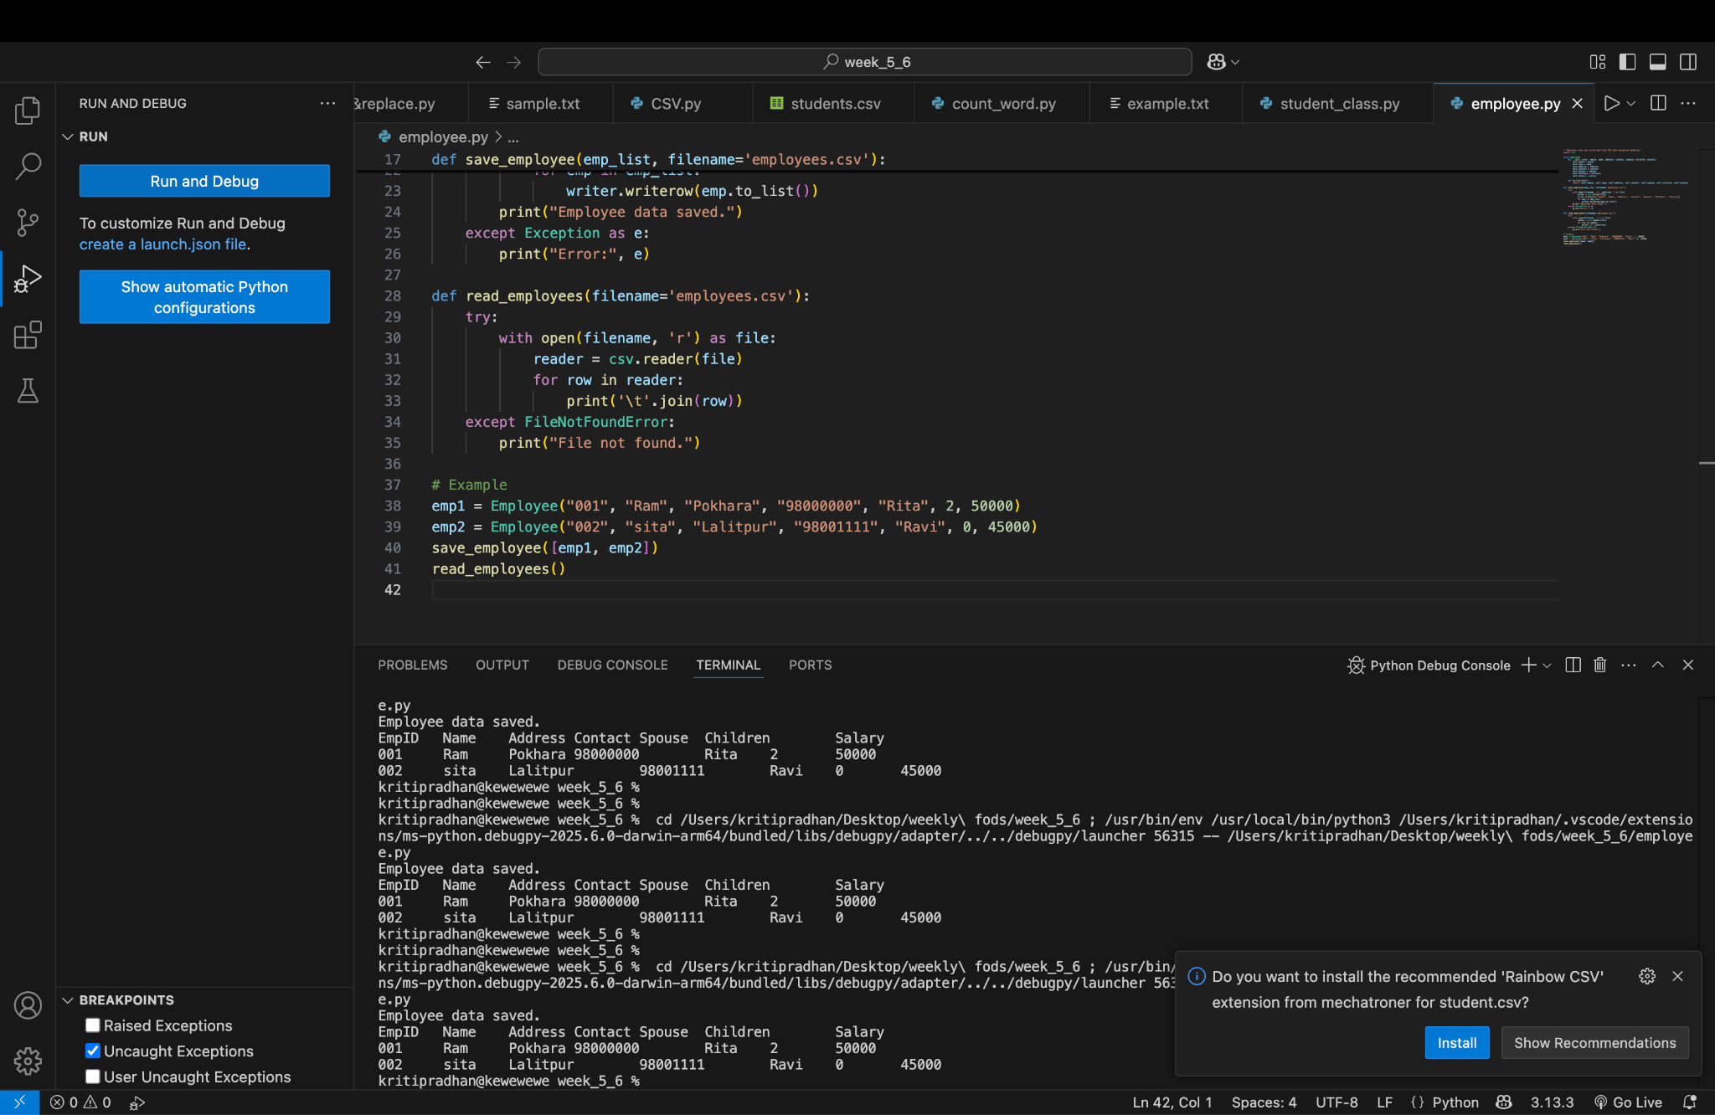

Library Book Management System
This program implements book issue/return/search features using OOP and file handling.
